Carlos Chong

Mie First

1. How does the spectrum change as you increase the dielectric constant of the surrounding materials? Try n = 1.45 glass, n = 1.76 for alumina

There is a red shift as we increase the dielectric constant for the varying materials.

1. There is a blue shift when the value n = 1.00, blue shift with

Ag, N = 0

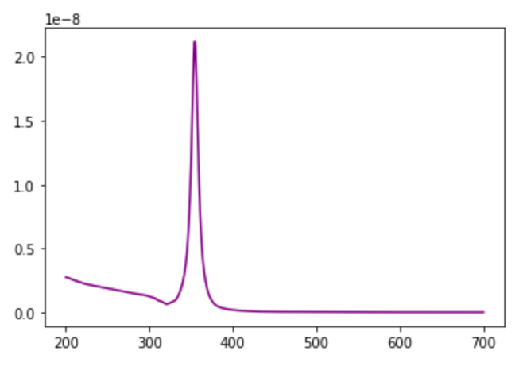

Ag, Glass, n = 1.45

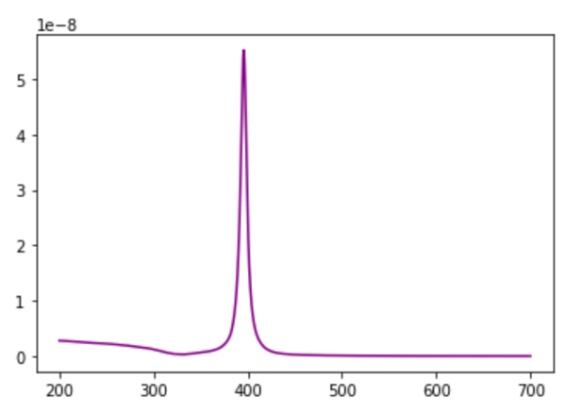

Ag, Alumina, n =1.76

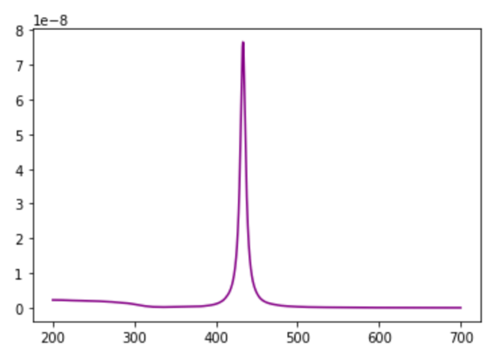

1. When you change Ag to Au.

I noticed a red shift from the values given by Ag. I also notice a broad peak distribution, which could be attributed from the plasmons which are forming from the change in material composition and dielectric constant in relation to the geometry and/or interface of the material.

Au, N = 1.45

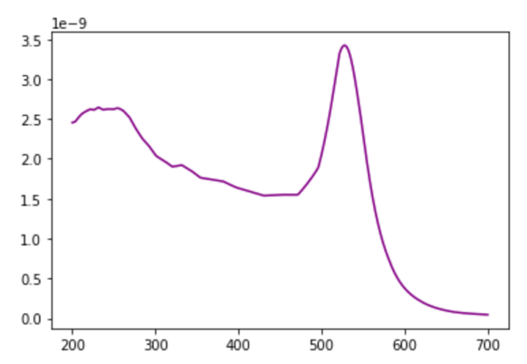

Au, N = 1.76

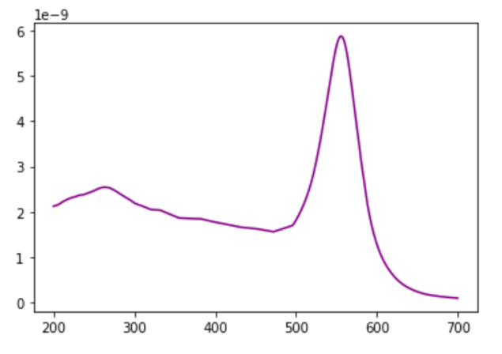

1. I notice the absorbance of Au is greater than the absorbance of Ag. I also notice that the peaks of real and imaginary are broader and more far apart in Au, while the peaks for Ag are closer together.

Ag and N=1.45

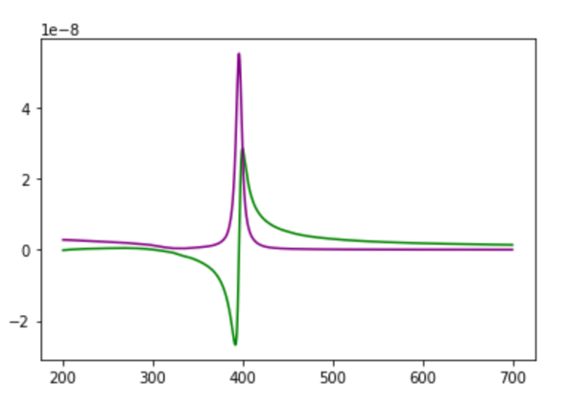

Ag and N =1.76

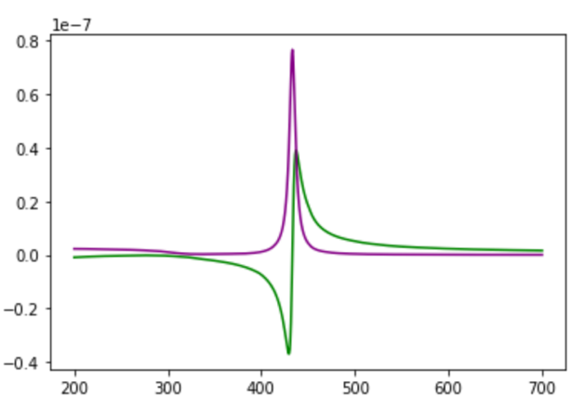

Au and N = 1.45

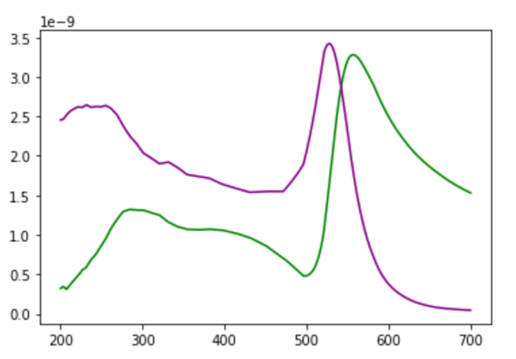

Au and N = 1.76

